**Methods:**

Leaves were collected in Guam and Samoa from a variety of locations and species and were taken back to the United States. There, the leaves were scanned and converted into a .jpg image. PowerPoint was then utilized to calculate the surface area of the leaves and the area of the holes on the leaves. These two values were then used to calculate the percent herbivory for a leaf and then put into an excel sheet that lists the location, species, and percent herbivory. From there, R was used to create a linear model and conduct a statistical analysis on the data. Utilizing the tidyverse package, the data set was cleaned and organized into a readable format for the computer. Then, using an anova model, a linear model analysis was conducted. Figures were then made using ggplot, and again analyzed further to determine which species had the most herbivory.

**Results and Analysis:**

The species Aglaia has the highest rate of herbivory on Guam from the selected leaves. As seen in Figure 1, the Aglaia species can have over 60% herbivory or less than 10% depending on the leaf. Cyno had the least amount of herbivory from the collected samples. When running anova and creating a linear model, the data set had a statistically significant P value when species and herbivory are plotted against each other. This means that there is a difference between the species and a correlation between the two variables. In the future, data from different islands will aid in further support of this question.

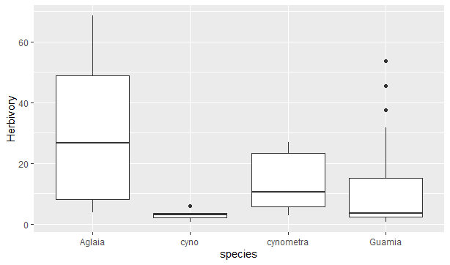Figure 1